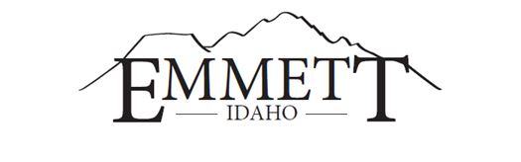
MAYOR:  Gordon W. Petrie, Presiding  ATTORNEYS:  Jake Sweeten  Tahja Jensen  CLERKS:  Lyleen Jerome, City Clerk  Shelly Tilton, County Clerk | EMMETT CITY COUNCIL  &  GEM COUNTY COMMISSIONERS  Joint Quarterly Meeting  Location: 501 E. Main Street  Emmett, ID 83617  October 10, 2023  6:00 P.M. | COUNCILORS:  Steve Nebeker, President  Thomas Butler  Jody Harris  Eltona Henderson  Gary Resinkin  Denise Sorenson  COMMISSIONERS:  Bill Butticci, Chairman  Kirk Wille  Mark Rekow

AGENDA
1. Call to Order
2. Pledge of Allegiance
4. Good Faith Amendments to Agenda ~ACTION ITEM~
5. Declaration of Conflicts of Interest
6. Announcements and Good of the Order

~ACTION ITEMS~
7. BUSINESS:

A. Update on Development – Extension of City Services

B. Frequency of Joint Meetings and Location

8. ADJOURN ~ACTION ITEM~

This institution is an equal opportunity provider. Any person needing special accommodations to participate in the above-noticed meeting should contact City Hall prior to the meeting at 501 East Main Street, Emmett, Idaho

