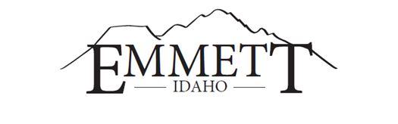
MAYOR:  Gordon W. Petrie, Presiding  ATTORNEYS:  Jake Sweeten  Tahja Jensen  CLERKS:  Lyleen Jerome, City Clerk  Shelly Tilton, County Clerk | EMMETT CITY COUNCIL  GEM COUNTY COMMISSIONERS  Live Stream  www.cityofemmett.org/meeting  501 E. Main Street  JOINT PUBLIC HEARING  May 23, 2023  6:00 P.M. | COUNCILORS:  Steve Nebeker, President  Thomas Butler  Jody Harris  Eltona Henderson  Gary Resinkin  Denise Sorenson  COMMISSIONERS:  Bill Butticci ,Chairman  Mark Rekow  Kirk Wille

AGENDA
1. Call to Order
2. Pledge of Allegiance
4. Good Faith Amendments to Agenda ~ACTION ITEM~
5. Declaration of Conflicts of Interest

~ACTION ITEMS~
6. Approval of Minutes – May 9, 2023 Hearing

7. PUBLIC HEARING – CONTINUANCE OF MAY 9, 2023 HEARING
A. Area of Impact Agreement
B. Staff Presentation
C. Public Comments
D. Close of Public Hearing
E. Decision of Public Hearing

8. ADJOURN ~ACTION ITEM~

This institution is an equal opportunity provider. Any person needing special accommodations to participate in the above-noticed meeting should contact City Hall prior to the meeting at 501 East Main Street, Emmett, Idaho

