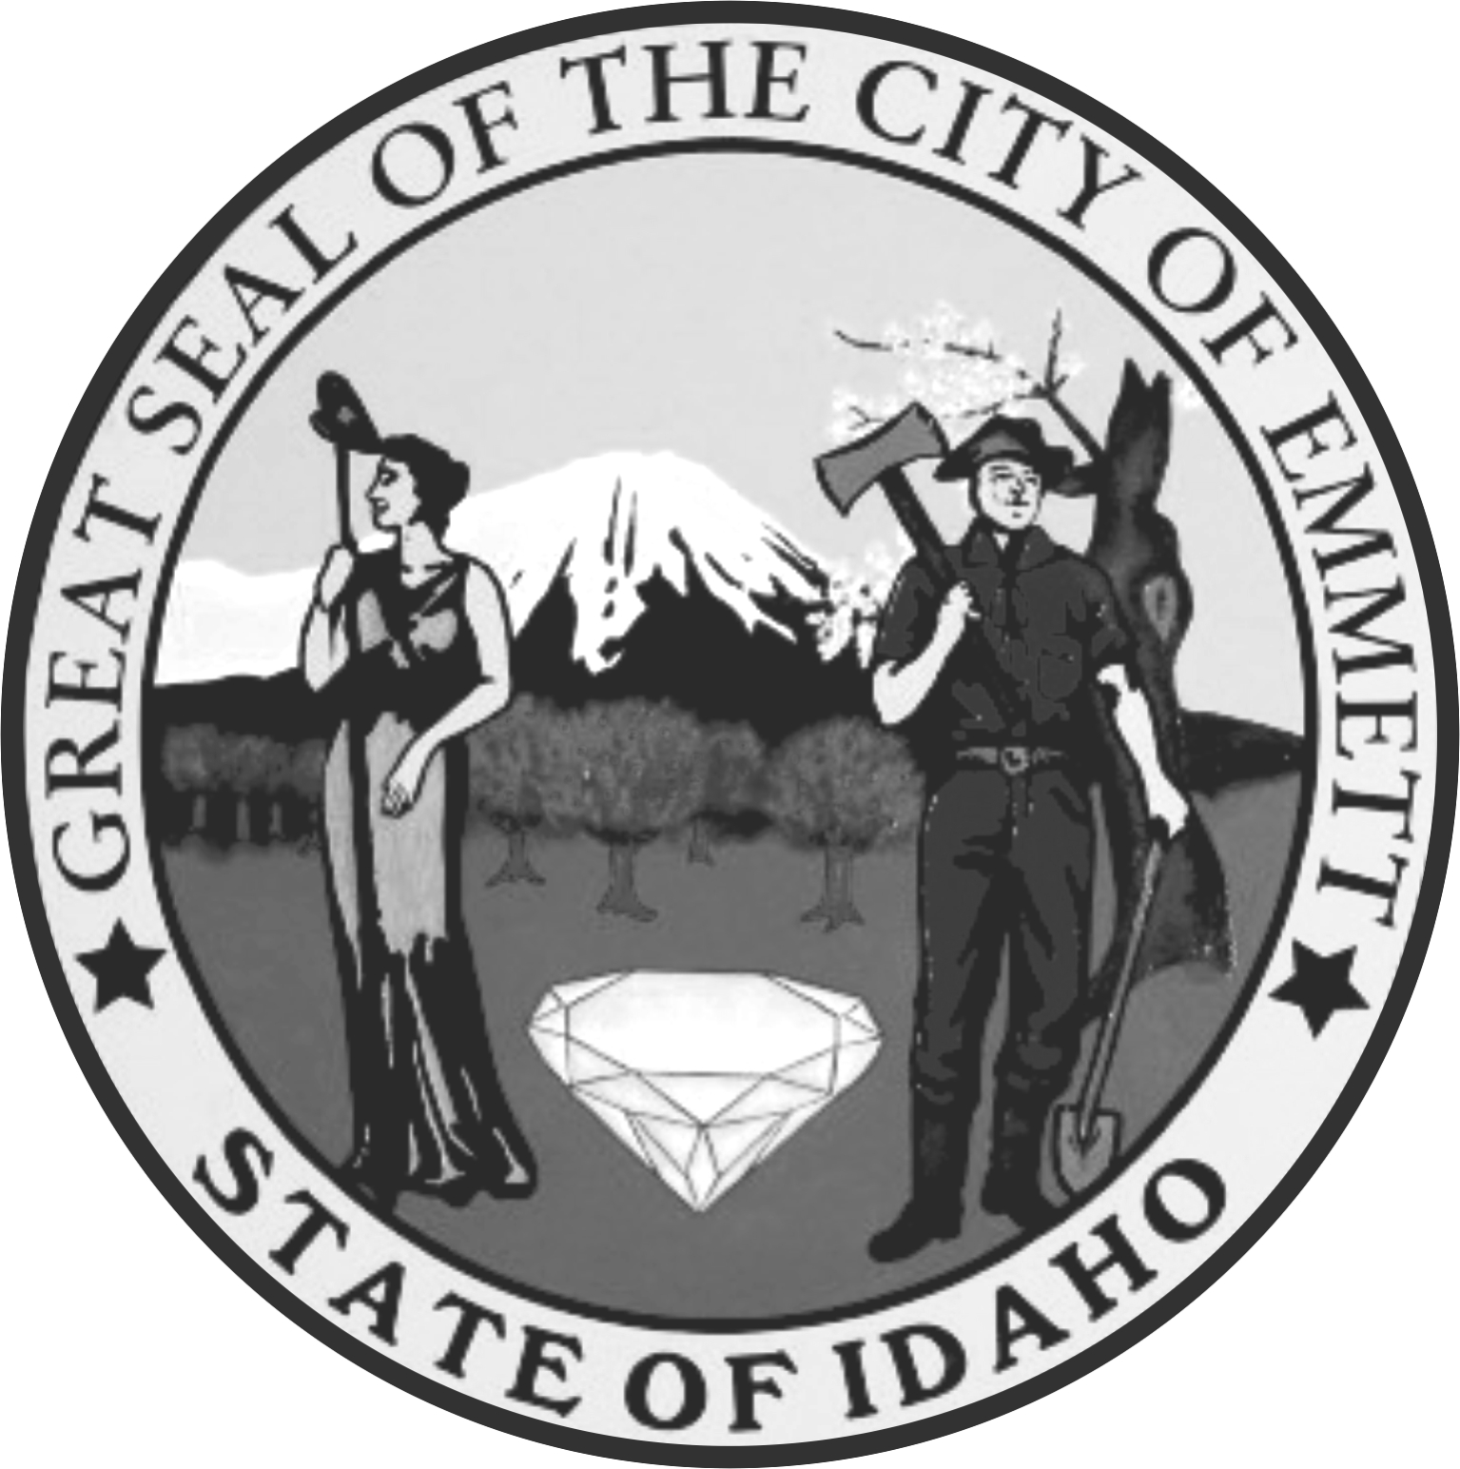 | City Council Meeting  City Council Chambers  501 East Main Street  Emmett, Idaho 83617  208-365-6050
 | Gordon Petrie, Mayor  Chrystal Whiteley, City Clerk  Jake Sweeten, Attorney | Council President:  Councilmen: | Michelle Welch  Shawn Alder  Eltona Henderson  Dave Hodges  Jefferson Jenkins  Mike Stout
Type of REGULAR Date: February 9, 2016 Time: 7:00 p.m.
Meeting:

AGENDA TOPICS

- Call to Order
- Pledge of Allegiance and Community Invocation – Pastor
- Amendments to the Agenda
- Declaration of Conflicts of Interest

Elected Officials:
- Mayor
  - Arbor Day Proclamation
- City Council

- Announcements and Good of the Order
1.

CONSENT AGENDA:
NOTICE TO THE PUBLIC: The consent agenda consists of items that are considered to be routine in nature and will be enacted in the form of one motion. Any item can be removed from the consent calendar and heard in its regular order at the request of any council member or the mayor

- Approval of Minutes –
- Approval of Permits – All bartender permits are subject to an approved background check
Bartender - Cassidy Barclay
- Items from the Public – All requests are subject to conditions set by staff
- Payment of Bills

NON CONSENT AGENDA:
A. Items from the Community

- Unfinished Business

- New Business
- Fiscal Year 2014/2015 Audit Report

- Department Head
A. Library – Alyce Kelley
  - Report
- Building Official/City Planner – Brian Sullivan
  - Report
- Superintendent of Public Works – Bruce Evans
  - Report
  - Keller Associates Pay App #9 – Water Master Plan – ($3,000.00)
  - Keller Associates Pay App # 17 – Sewer Master Plan – ($1,725.00)
- City Clerk – Chrystal Whiteley
  - Report
- Fire Chief – Curt Christensen
  - Report
  - Grant Writing Proposal
- Systems Administrator – Mike Knittel
  - Report
- Chief of Police/Code Enforcement – Gary Scheihing
  - Report
- Engineer –
  - Report

- Adjourn

This institution is an equal opportunity provider.
Any person needing special accommodations to participate in the above-noticed meeting should contact City Hall
prior to the meeting at 501 East Main Street, Emmett, Idaho

